
Helping local people face incurable illness and bereavement, supporting them, their families, friends, and carers.

Recruitment pack
Senior Individual Giving Officer
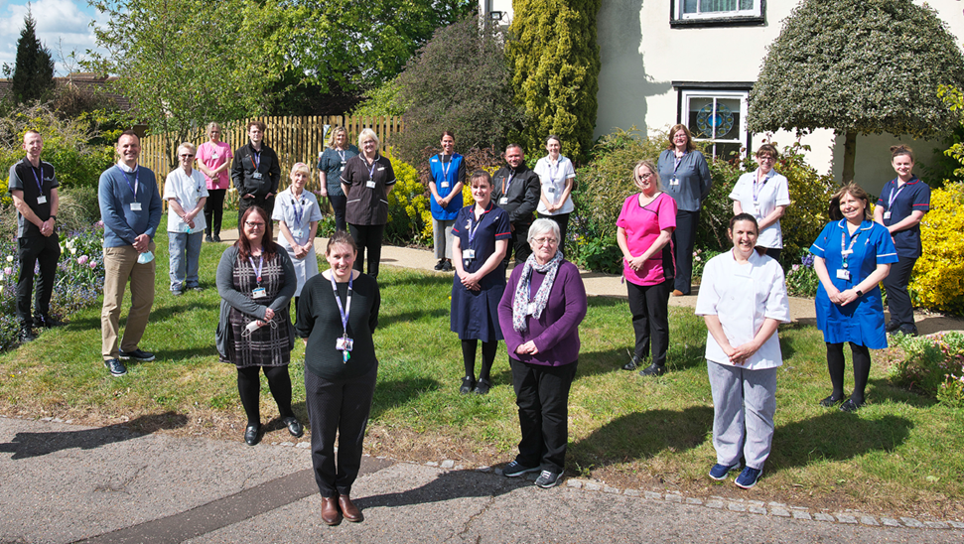

Who is St Helena?

Here at St Helena, we believe that everyone living with an incurable illness has the right to live and die with choice, compassion, and dignity. Families deserve to be cared for and anyone coping with loss should be supported through their grief.

Our vision is to create a community where everyone knows that as the end of their story draws near, they will be cared for and die where they choose to be; where loved ones can make the most of life together, surrounded by people who care and support one another.

Since we opened in 1985, this belief drives us to provide the best end of life care and bereavement support to everyone in northeast Essex, not just today but for years to come.

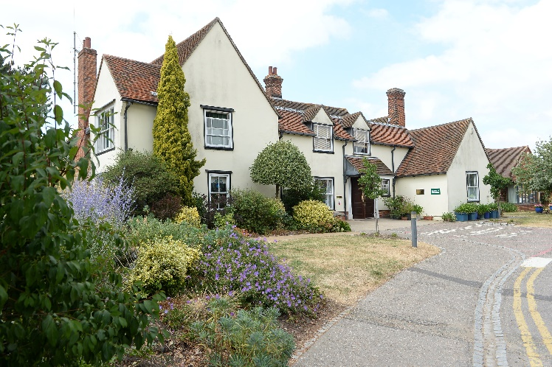

Every year we support more than 4,000 local people facing dying, death and bereavement.
By focusing on their physical, emotional, and spiritual needs, we aim to bring comfort and relief to all those who need it, offering the people of northeast Essex individual care and total support, regardless of their diagnosis or personal circumstances.
By visiting them in their homes, over the phone with our 24/7 advice line, and at the Hospice in Colchester, through all the smiles and all the tears we guide those who need us, because we believe in making every memory matter.
Not only do we support local people in our community facing incurable illness, but we also support adults and children living in northeast Essex through bereavement, regardless of how or where their loved one died.
St Helena is an independent charity, providing our services free of charge. The equivalent of 7 out of 10 of the patients and families we care for and support are funded by people in our local community giving donations, buying from our shops, playing our lottery, and leaving gifts in Wills.
We rely on the help and generosity of our fundraisers, donors, and volunteers to continue to provide our services. Without them we wouldn’t be here.

What does the role entail?
Place of work | Phoenix Square, Wyncolls Road, Colchester, CO4 9AS
Salary | £28k
Contract type | 37.5 hours per week, permanent Hybrid working.  .
Reports to | Senior Philanthropy Manager
Location | Hybrid working – 2/3 days a week in office
Budget responsibility | None
Travel | Some

• Take your career to the next level working with amazing like-minded people
• Work for a company who gives you a platform to do amazing things
• Be in a job where you really make a difference
What are we looking for?
- Excellent interpersonal skills
- Well organised and able to manage a busy workload.
- IT literate and comfortable with Microsoft Packages
- Effective communication skills, with good written and verbal presentation skills
- Able to work effectively as a team, but also has own initiative.
- Driving Licence essential
Job Description
KEY WORKING RELATIONSHIPS
All staff and volunteers at St Helena  Supporters, donors, patients and families | Counterparts in other settings  External agencies and suppliers  Local companies and community groups
KEY PRIORITIES
- Collaborate with the Senior Philanthropy Fundraising Manager to deliver strategic, multi-channel campaigns across donor development, supporter acquisition, and prize-led fundraising.
- Deliver a portfolio of creative and inspiring initiatives that place the supporter at the heart of every interaction.
- Maximise retention and long-term value of the supporter base through effective stewardship and data-driven engagement.
- Use insight, data, and supporter feedback to inform campaign development and relationship building.
Build strong internal relationships, particularly with clinical teams, to inform emotive and authentic supporter communications.

DUTIES & RESPONSIBILITIES
Strategic & Campaign Management
- Support delivery of Individual Giving KPIs and income targets in line with strategic objectives.
- Monitor and report on income and expenditure across campaigns, ensuring alignment with agreed budgets.
- Develop and implement innovative methods for acquiring new supporters and reactivating lapsed donors.
- Lead on integrated campaign planning, including direct mail, and communication.
- Mid-level donor engagement: Developing specific strategies and stewardship plans to cultivate relationships with mid-level donors and increase their giving over time.
Regular Giving & Stewardship
- Design and deliver outstanding stewardship plans, including personalised communications and impact updates.
- Implement acquisition and uplift strategies working with the marketing team.
- Develop effective welcome and thanking programs to enhance supporter experience.
- Collaborate across Fundraising, Income Generation, and hospice teams to create seamless supporter journeys.
Appeals & Raffles
- Project manage multi-channel appeals and direct mail programs from concept to evaluation.
- Ensure appeals are segmented to attract both new and existing donors.
- Support the growth of income from raffles and prize-led fundraising.
- Work with marketing and clinical teams to source compelling case studies and develop emotive fundraising asks.
Data, Reporting & Insight
- Use Raiser’s Edge and other tools to analyse donor behaviour, segment audiences, and ensure data hygiene.
- Produce post-campaign analysis reports and share insights to inform future activity.
- Monitor campaign performance and provide regular updates to the Senior Philanthropy Manager.
Additional Responsibilities
- Represent Individual Giving at events and external initiatives such as Hospice Care Week and Dying Matters Week.
- To be responsible for own administration and ensure that all relevant donor records are kept up to date on CRM Database.
- To attend events and engagements where appropriate outside normal working hours, including some weekends.
- Maintain accurate donor records and ensure compliance with GDPR and charity regulations.
- Build strong internal relationships to embed fundraising within the culture of St Helena Hospice.
- Liaise with external agencies, suppliers, and professional bodies as required.

What is the team like?
Team structure

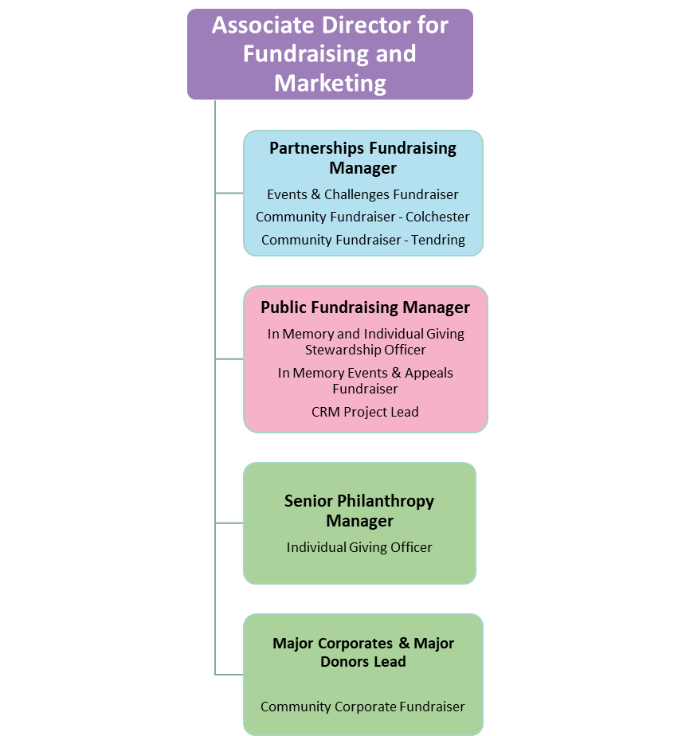

What is the culture like?
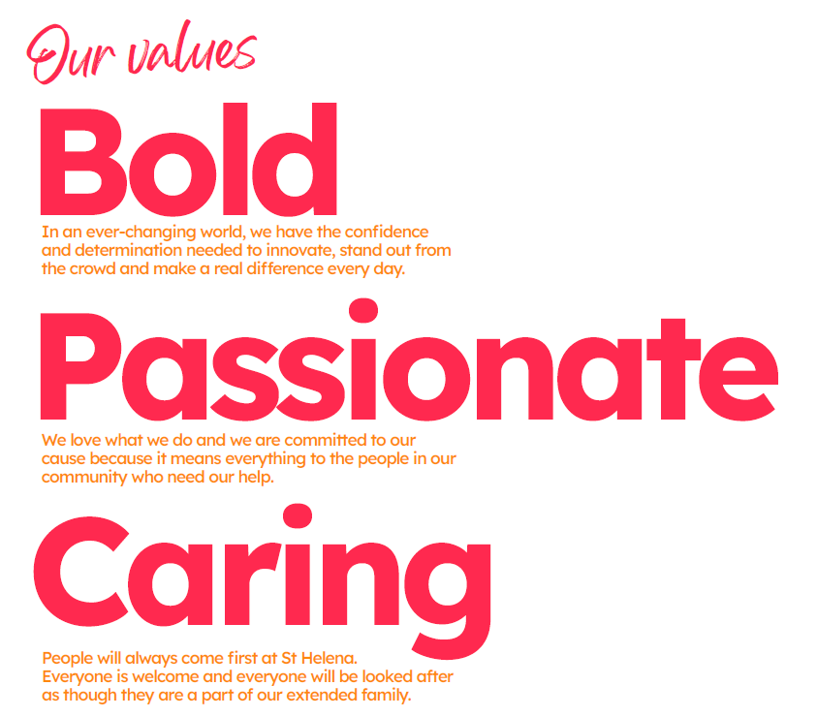
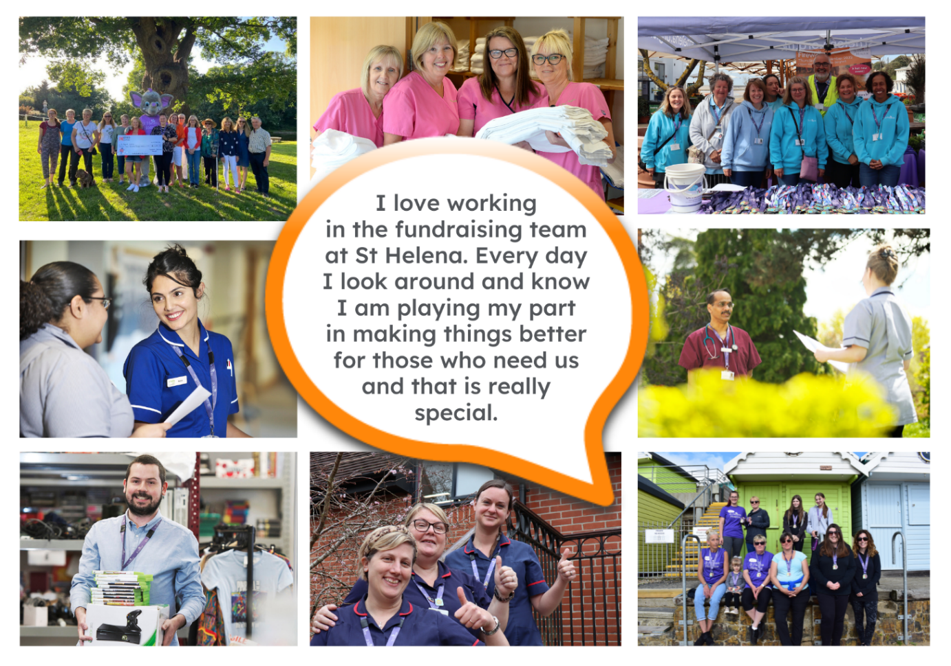
“It takes an amazingly special place with exceptionally special people to make the hardest times of your life turn into the most precious and so full of love.”

The passion
Whether you work within the clinical team, one of our support services or in the commercial team, each team member is incredibly passionate about what they do.
Working for St Helena is a privilege. There are not many companies you could work for that really make a difference to the local community as St Helena does.

This is not just a belief held by those working here; it’s feedback we often receive from the patients and families we 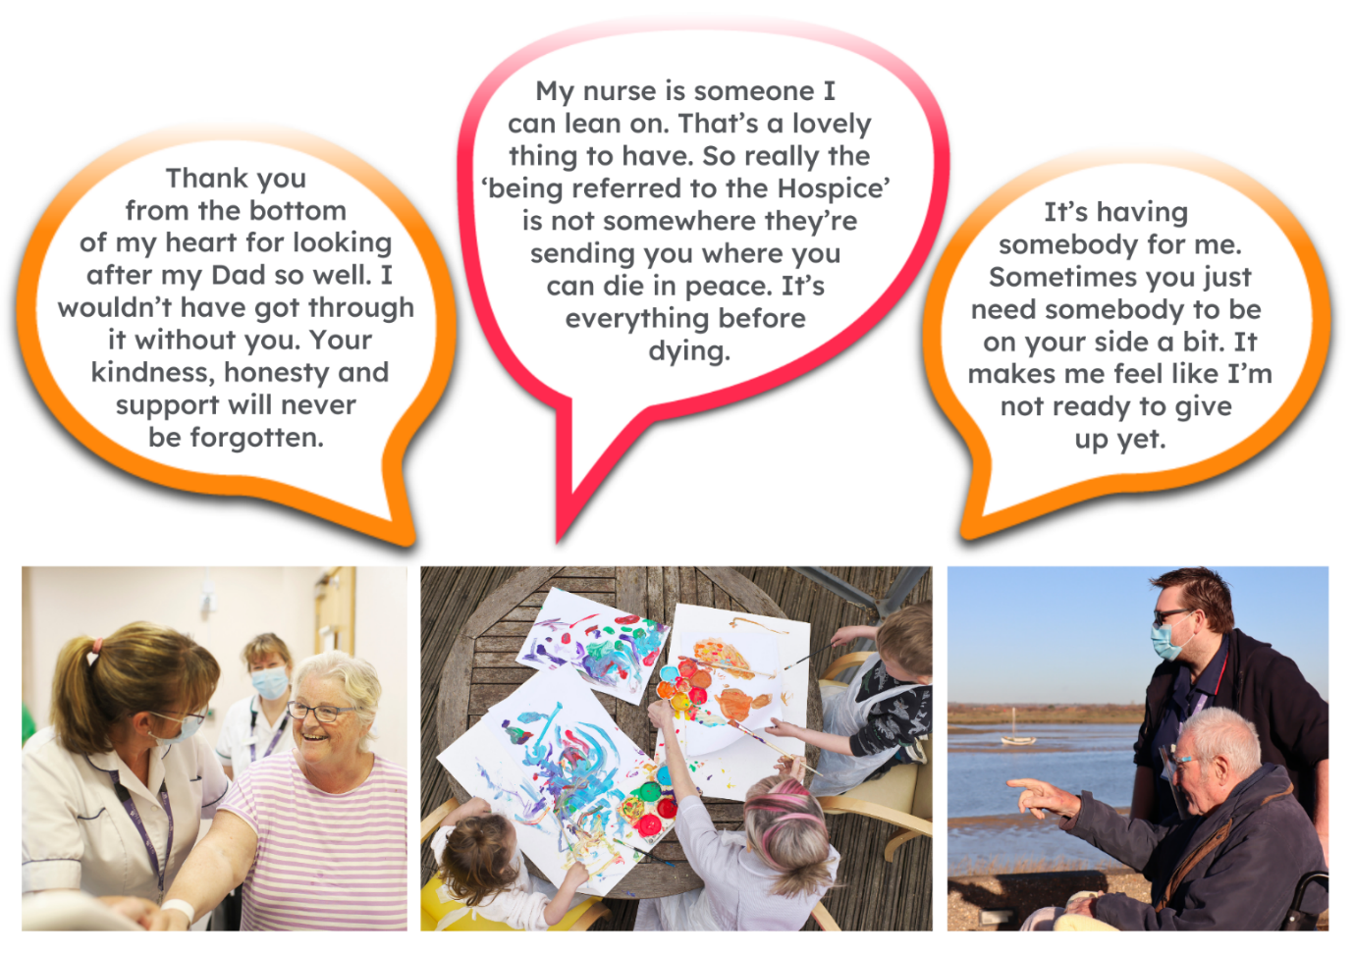

Can you really make a difference?

44,371 calls received by SinglePoint from patients, families & health care professionals last year
4,892 local people St Helena cared for who faced death, dying & bereavement in 2024/25

The benefits
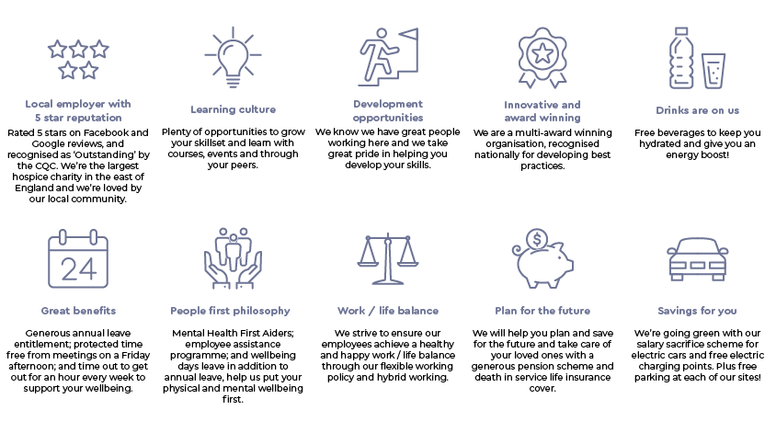
Not only is working at St Helena rewarding, but there are also a vast number of benefits too!
Next steps
We hope we have given you a bit of an idea of what an amazing place St Helena is to work and you’re keen to find out more!
Here are the next steps:
- To find out more about St Helena, please visit our website.

- Apply for the position!

- Please contact us on the details below if you have any questions before or after you apply, we’ll be happy to talk through!

- Follow us on social media @StHelenaHospice to keep in the loop!

We look forward to meeting you!
Contact us :
Jclarke@sthelena.org.uk
Tel: 01206 931468

Registered Charity Number 280919. Registered Office: Myland Hall, Barncroft Close, Highwoods, Colchester, CO4 9JU

