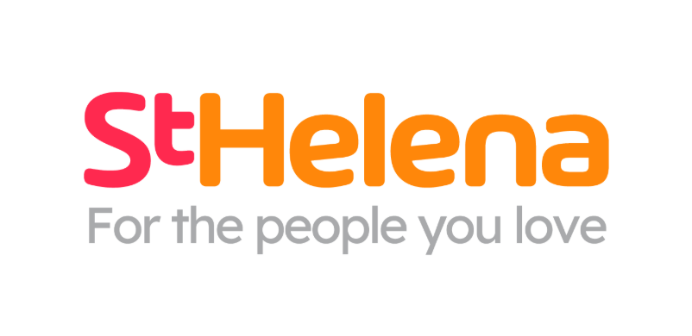



Helping local people face incurable illness and bereavement, supporting them, their families, friends and carers.
Recruitment pack
Manningtree Assistant Manager

Who is St Helena?

Here at St Helena, we believe that everyone living with an incurable illness has the right to live and die with choice, compassion and dignity. Families deserve to be cared for and anyone coping with loss should be supported through their grief.

Our vision is to create a community where everyone knows that as the end of their story draws near, they will be cared for and die where they choose to be; where loved ones have the opportunity to make the most of life together, surrounded by people who care and support one another.

Since we opened in 1985, this belief drives us to provide the best end of life care and bereavement support to everyone in north east Essex, not just today but for years to come.

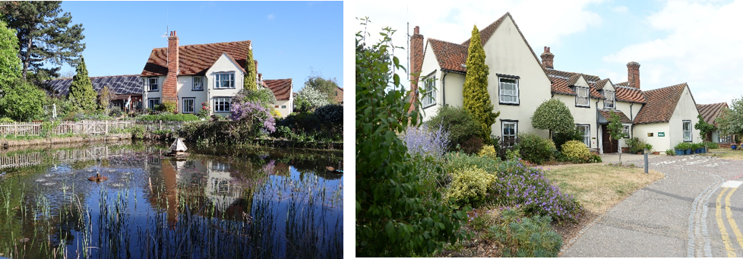

Every year we support more than 4,100 local people facing dying, death and bereavement.
By focusing on their physical, emotional and spiritual needs, we aim to bring comfort and relief to all those who need it, offering the people of north east Essex individual care and total support, regardless of their diagnosis or personal circumstances.
By visiting them in their homes, over the phone with our 24/7 advice line, and at the Hospice in Colchester, through all the smiles and all the tears we guide those who need us, because we believe in making every memory matter.
Not only do we support local people in our community facing incurable illness, but we also support adults and children living in north east Essex through bereavement, regardless of how or where their loved one died.
St Helena is an independent charity, providing our services free of charge. The equivalent of 7 out of 10 of the patients and families we care for and support are funded by people in our local community giving donations, buying from our shops, playing our lottery and leaving gifts in Wills.
We rely on the help and generosity of our fundraisers, donors and volunteers to continue to provide our services. Without them we wouldn’t be here.
What does the role entail?

Place of work | Manningtree
Salary | £24,852.59
Contract type | Permanent, 5 days, 37.5 hours
Reports to | Retail, Cafe and Donation Centre Manager
Manages | Volunteers and site operations when delegated or providing management cover

- Take your career to the next level working with amazing like-minded people
- Work for a company who gives you a platform to do amazing things
- Be in a job where you really make a difference

What are we looking for?
Customer Focus – builds positive relationships with customers, donors and volunteers, ensuring everyone feels welcomed, valued and appreciated.
Leadership and Team Development – leads by example, encouraging and supporting others to give their best while creating a positive, inclusive team environment.
Organised and Reliable – Take pride in maintaining high standards, managing priorities effectively and ensuring the shop operates efficiently and safely.
Proactive and Resilient – approaches challenges with a positive attitude, uses initiative to find solutions and remains calm and adaptable in a fast-paced environment.

JOB DESCRIPTION

JOB OVERVIEW
JOB TITLE | Manningtree Assistant Manager
DEPARTMENT | Retail, Cafe and Donation Centre
LOCATION | Manningtree
REPORTS TO | Retail, Cafe and Donation Centre Manager

KEY WORKING RELATIONSHIPS
- Customers, donors and the local community  - Shop staff, Assistant Manager(s) and volunteers, Retail, Cafe and Donation Centre Shop Manager, Duty Manager,  - Area Manager and wider Retail team including  Donation Centre, E-commerce, Retail, Cafe and Donation Centre Administration, | - Finance,  - Marketing and Communications,  - Volunteer Services, People & Culture,  - Estates and Health & Safety teams  - Approved suppliers, contractors, recycling partners and community partners
KEY PRIORITIES
- Support the Retail, Cafe and Donation Centre Shop Manager or Duty Manager with day-to-day shop operations and agreed income, Gift Aid and performance objectives
- Create an excellent customer and donor experience through service, shop presentation, stock availability and local relevance.
- Support the recruitment, induction, training, supervision and development of a capable and inclusive volunteer team.
- Ensure the efficient receipt, sorting, safe storage, control and movement of donated stock, working closely with the Donation Centre and other shops.
- Ensure the shop follows all current approved policies, procedures, SOPs, product-safety controls and mandatory training requirements.
- Promote the shop through suitable local content and community activity within brand, social media, consent and approval requirements.
- Take operational responsibility for the shop when the Retail, Cafe and Donation Centre Shop Manager or Duty Manager are absent or when delegated, protecting people, stock, assets, funds, information and reputation.
DUTIES & RESPONSIBILITIES
ROLE PURPOSE
To support the Retail, Cafe and Donation Centre Manager and Duty Manager in operating a welcoming, safe and commercially successful St Helena shop that maximises sustainable income from donated and new goods. The post holder will supervise and support volunteers, maintain strong customer, stock and compliance standards, and take operational responsibility for the shop when the Retail, Cafe and Donation Centre Manager or Duty Manager are absent or when delegated. The post holder will also support or oversee cafe operations when required and appropriately trained.
COMMERCIAL PERFORMANCE AND CUSTOMER EXPERIENCE
Support daily trading activity to maximise income from donated goods, new goods, cafe and approved initiatives, including taking responsibility when providing management cover.
Understand relevant shop targets and performance information and support agreed improvement actions with the Retail, Cafe and Donation Centre Shop Manager.
Maintain strong pricing, merchandising, display, replenishment and seasonal standards.
Promote Gift Aid accurately and maintain the required customer conversation, labelling and audit trail.
Deliver courteous, inclusive customer and donor service and resolve concerns within authority levels.
Use customer feedback, local knowledge and available data to improve sales, donations and community reach.
Support the Shop Manager with the creation, promotion, roll out and delivery of a workshop programme.
DONATIONS, STOCK PROCESSING AND DISTRIBUTION
Manage the safe and efficient receipt of donations, ensuring donors are welcomed and goods are moved promptly into the approved sorting process.
Ensure donated goods are sorted, checked, priced, stored and selected appropriately to maximise income and comply with current product and quality standards.
Maintain clean, organised and secure back-of-house areas with safe access routes, clear storage locations and strong housekeeping.
Monitor stock levels, capacity, seasonal need and rate of sale; request, transfer or redistribute stock in collaboration with the Donation Centre and other shops.
Prepare stock transfers accurately and maintain any required records for goods received, sent, recycled or disposed of.
Identify high-value, specialist, collectable, retro or unusual items and route them to approved e-commerce, specialist or alternative sales channels.
Apply clear controls for staff and volunteer access to donated stock, staff purchases and movement of goods to protect stock and public confidence.
Follow approved recycling and disposal arrangements, maximise legitimate return and minimise waste.
Support agreed collections, deliveries and logistics activity, ensuring goods are ready, access is safe and relevant information is communicated.
PEOPLE LEADERSHIP AND VOLUNTEER MANAGEMENT
Help welcome, induct, train, coach and support volunteers in line with approved processes and delegated responsibilities.
With the Shop Manager and Duty Manager, plan fair, effective rotas within agreed budgeted hours and maintain suitable shop cover.
Allocate tasks according to competence and operational need, ensuring controlled activities are undertaken only by appropriately briefed or trained people.
Set clear expectations, recognise contribution and create an inclusive environment where people can speak up.
Work with the Shop Management team to address conduct, capability, attendance, service or teamwork concerns promptly with appropriate support.
Provide constructive day-to-day feedback to volunteers and share relevant development or conduct concerns with the Retail, Cafe and Donation Centre Shop Manager.
MANAGEMENT COVER, CAFE SUPPORT AND DELEGATED RESPONSIBILITY
Act as the responsible person for the shop, and the cafe where applicable, when the Retail, Cafe and Donation Centre Shop Manager or Duty Manager are absent or when formally delegated.
Open and close the shop and cafe where applicable, manage keys and alarms, complete required checks and maintain safe staffing and trading arrangements.
Coordinate shop and cafe volunteers, allocate tasks according to competence and respond to operational issues throughout the shift.
Complete tills, cash handling, banking preparation, refunds, petty cash, Gift Aid and required cafe trading records within authority and current procedures.
Deal with customer concerns, incidents, premises issues and staff or volunteer matters within authority, escalating promptly where required.
Maintain a clear handover for the Retail, Cafe and Donation Centre Shop Manager covering shop and cafe trading, cash, stock, staffing, incidents, actions and unresolved risks.
Maintain cafe opening, service, cleanliness, allergen, food hygiene, temperature-control, stock-rotation, waste and closing requirements in line with current approved procedures.
Ensure cafe staff and volunteers are suitably deployed and that food-safety, equipment, staffing or customer-service concerns are acted on promptly and escalated where necessary.
Include cafe trading, staffing, incidents, compliance checks and outstanding actions in the management handover.
POLICIES, SOPS, QUALITY AND COMPLIANCE
Read, understand and follow current approved policies, procedures, SOPs, work instructions and site-specific documents, including those relevant to cafe operations when providing cafe support.
Brief and train relevant staff and volunteers when procedures are introduced or revised, remove superseded practices and retain evidence where required.
Apply approved controls for electrical items, toys, jewellery, furniture, textiles, unwanted goods and other regulated or higher-risk products.
Follow current rules for staff and volunteer purchases, discounts, personal trading, refunds, online selling and conflicts of interest.
Carry out required audits, logs and checks; take corrective action and escalate breaches, unsafe practice, suspected fraud, loss or near misses.
Contribute feedback to improve Retail, Cafe and Donation Centre procedures while continuing to follow the approved process until change is formally agreed.
STORE PROMOTION, CONTENT AND COMMUNITY ENGAGEMENT
Support and plan local activities that supports footfall, donations, sales, volunteer recruitment and awareness of St Helena.
Create accurate, engaging content about stock, displays, events, promotions and donation needs for approved channels.
Work with Marketing and Communications and Retail, Cafe and Donation Centre colleagues to follow brand standards, campaigns and approvals.
Follow current social media guidance, including authorised access, account security, confidentiality, data protection, safeguarding, copyright and consent.
Keep promotional prices, dates and details accurate and remove or update out-of-date content.
Build appropriate local relationships and seek approval before committing St Helena to partnerships, expenditure or public statements.
HEALTH, SAFETY, SAFEGUARDING AND SECURITY
Maintain safe shop, cafe, front-of-house and back-of-house environments for customers, donors, staff, volunteers and contractors.
Complete, review and act on relevant risk assessments, including fire, manual handling, lone working, COSHH, storage and individual requirements.
Ensure emergency, incident, first-aid, fire and evacuation arrangements are understood and recorded.
Act as principal key holder where required and follow opening, closing, alarm, cash security and emergency call-out procedures.
Ensure premises, storage, fixtures and equipment are safe and maintained; report defects and prevent unsafe use.
Recognise and report safeguarding concerns in line with current policy.
FINANCE, RECORDS AND SYSTEMS
Complete shop and cafe till, cash handling, banking, petty cash, refund and income processes accurately and on time.
Control expenditure and additional hours within delegated authority and budget.
Maintain accurate records for sales, Gift Aid, stock transfers, waste, staff purchases, training, safety, incidents and maintenance.
Use approved Retail, Cafe and Donation Centre, finance, people and reporting systems accurately and protect logins, personal data and sensitive information.
Monitor stock flow and work with the Donation Centre, E-commerce and other shops to place goods where they can achieve the best return.
COMMUNICATION AND CONTINUOUS IMPROVEMENT
Organise workload effectively, meet deadlines and keep the Retail, Cafe and Donation Centre Shop Manager informed of performance, stock, risks and resource needs.
Attend Retail, Cafe and Donation Centre meetings, training and governance briefings and share learning across the Retail estate.
Support agreed trials, events, campaigns and operational changes.
Undertake other reasonable duties consistent with the nature and level of the role.

GENERAL - Applicable to all roles at St Helena
All of the above activities are governed by the operational policies, Standing Financial Instructions, policies and procedures and standards of St Helena as well as legislation and professional standards and guidelines.
All employees must comply with St Helena’s Equal Opportunity Policy and must not discriminate on the grounds of sex, colour, race, ethnic, or national origins, marital status, age, disability, sexual orientation or religious belief.
Employees have a responsibility to themselves and others in relation to managing risk, health and safety and will be required to work within the policies and procedures laid down by St Helena. All staff have a responsibility to access occupational health, other staff support services and/or any relevant others in times of need and advice.
All employees have the right to work in an environment which is safe and to be protected from all forms of abuse, violence, harassment and undue stress. All employees are responsible for helping to ensure that individuals do not suffer harassment or bullying in any form. All employees will be personally accountable for their actions and behaviour in cases of complaint of harassment or bullying.
St Helena is a smoke free organisation. Smoking is not allowed in any St Helena premises. If you would like help to give up smoking you should contact your GP or call the NHS Stop Smoking Help Line.
St Helena is a charity and all staff are responsible to ensure that funds are spent in the most sustainable and efficient way. Staff may also be encouraged to join fundraising and other business-related activities to promote the charity’s financial well-being.
PERSONAL DEVELOPMENT
Be aware of own development needs and take appropriate action. Keep updated of evidence based practice and government policies related to care. Act as an effective role model at all times.
PROFESSIONAL DUTIES
To maintain personal professional status, ensuring that the requirements laid down by the relevant professional body for registration are compliant.
Exercise professional accountability as guided by the relevant professional body and maintained in accordance with the policies of the department and St Helena.
ANNUAL APPRAISAL
The post holder will be appraised on an annual basis and the process will include a review of the past year’s performance, setting of aims and objectives for the coming year and identification of educational needs.
TRAINING
All staff will undertake such training as is necessary to perform the duties allocated and any mandatory requirements of St Helena. This will include mandatory training in line with your job role.
QUALITY
St Helena aims towards maintaining the goodwill and confidence of its own staff and of the general public. To assist in achieving the objective it is essential that at all times, employees carry out their duties in a courteous and sympathetic manner.
CONFIDENTIALITY
Your attention is drawn to the confidential nature of information collected and used throughout the NHS. The unauthorised use or disclosure of patient, staff or other personal information is a dismissible offence. The unauthorised disclosure of information could also result in a prosecution for an offence, or action for civil damaged, under GDPR.
SAFEGUARDING CHILDREN AND VUNERABLE ADULTS
All St Helena employees are required to act in such a way that at all times safeguards (and promotes) the health and well-being of children and vulnerable adults. Familiarisation with and adherence to St Helena safeguarding policies is an essential requirement of all employees as is participation in related mandatory/statutory training.
VALUES AND BEHAVIOURS
St Helena’s core values and behaviours will be embedded in our recruitment, training and development review and decision making process.
Bold | In an ever-changing world, we have the confidence and determination needed to innovate, stand out from the crowd and make a real difference every day.
Passionate | We love what we do and we are committed to our cause because it means everything to the people in our community who need our help.
Caring | People will always come first at St Helena. Everyone  is welcome and everyone will be looked after as though they are a part of our extended family.
This job description is not an exhaustive document but is a reflection of the current position. Details and emphasis may change in line with service needs and after consultation with the post holder.

PERSON SPECIFICATION

ATTIRIBUTE | ESSENTIAL | DESIRABLE
Qualifications | Good standard of literacy and numeracy demonstrated through qualifications or equivalent experience. | Relevant retail, leadership, customer service, logistics or health and safety qualification.  Food Safety & Hygiene certificate
Experience | Retail, cafe or customer-facing experience; supporting or supervising others; cash handling; stock control; accurate record keeping; delivering strong service. | Charity retail; cafe or hospitality operations; supervising volunteers; acting as a key holder or providing management cover; Donation Centre or warehouse activity; Gift Aid.
Skills & Knowledge | Understanding of Stock Control  Able to follow policies and SOPs, maintain records, manage risk and escalate concerns.  Confident using Microsoft 365 and retail systems including social media content or digital performance | Experience of pricing and merchandising  Experience of carrying out audits, risk assessments  Understanding and/or experience in food hygiene, allergen awareness, information.  Experienced in working with Volunteers
Communication | Clear and courteous communication with customers, donors, colleagues and volunteers;  able to give clear instructions, provide feedback and raise concerns appropriately. | Experience of supporting local community engagement.
Qualities | Organised; reliable; positive; calm under pressure; flexible; practical; creative;  Committed to St Helena’s purpose and values.  Able to work a rota including weekends, travel to other St Helena locations and undertake practical shop, cafe, stock and donation-handling duties with reasonable adjustments where needed. | Knowledge of St Helena and the local community; full driving licence and access to transport where required operationally Commercially minded.

What is the team like?
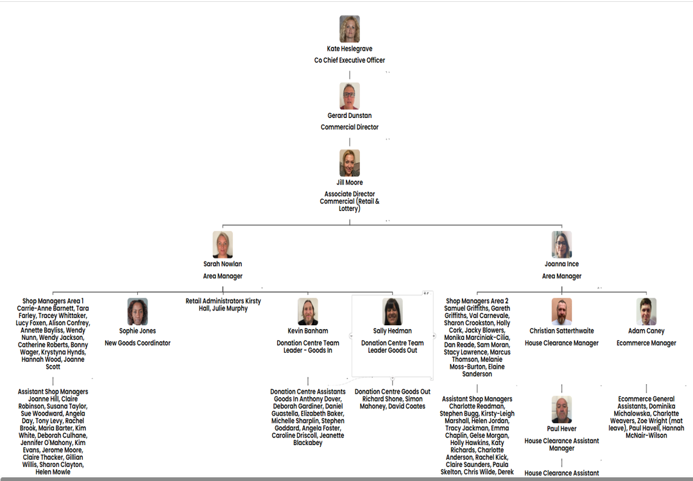
Meet some of the team
Commercial Director – Gerard Dunstan
Associate Director Commercial – Jill Moore

Area Manager – Sarah Nowlan

Area Manager – Jo Ince

What is the culture like?
Our values are incredibly important to us. But at St Helena, values are much more than just words…

They are feelings….
“It takes an amazingly special place with exceptionally special people to make the hardest times of your life turn into the most precious and so full of love.”

The passion
Whether you work within the clinical team, one of our support services or in the commercial team, each and every team member is incredibly passionate about what they do.
Working for St Helena is a privilege. There’s not many companies you could work for that really make a difference to the local community as St Helena does.
This isn’t just a belief held by those working here; it’s feedback we often receive from the patients and families we support:

Can you really make a difference?

- Last year, we helped 4,171 patients and families facing incurable illness and bereavement. More than we have ever supported before!

- 47,421 calls were made to our SinglePoint 24/7 phoneline.

- £585,058 was raised from local individuals, groups, schools and businesses in the community.

- None of this can be achieved without our amazing team. Everyone plays a part!

The benefits
Not only is working at St Helena rewarding, but there are also a huge number of benefits too!
Next steps
We hope we’ve given you a bit of an idea of what an amazing place St Helena is to work and you’re keen to find out more!
Here are the next steps:
- To find out more about St Helena, please visit our website www.sthelena.org.uk

- Apply for the position!

- Please contact us on the details below if you have any questions before or after you apply, we’ll be happy to talk through!

- Follow us on social media @StHelenaHospice to keep in the loop!

We look forward to meeting you!
Contact us:
Jo Ince
jince@sthelena.org.uk

Registered Charity Number 280919. Registered Office: Myland Hall, Barncroft Close, Highwoods, Colchester, CO4 9JU

