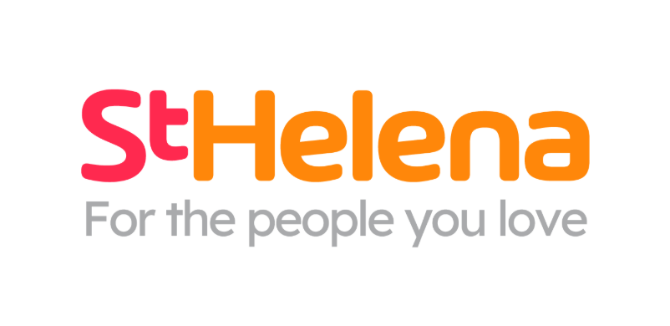

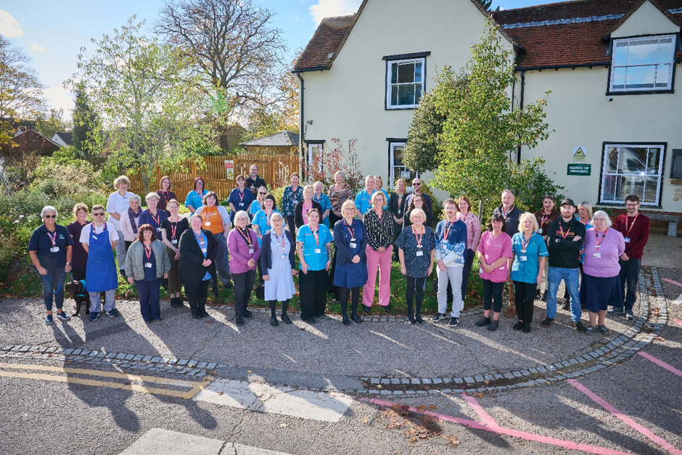

Helping local people face incurable illness and bereavement, supporting them, their families, friends and carers.
Recruitment pack
Manningtree Manager

Who is St Helena?

Here at St Helena, we believe that everyone living with an incurable illness has the right to live and die with choice, compassion and dignity. Families deserve to be cared for and anyone coping with loss should be supported through their grief.

Our vision is to create a community where everyone knows that as the end of their story draws near, they will be cared for and die where they choose to be; where loved ones have the opportunity to make the most of life together, surrounded by people who care and support one another.

Since we opened in 1985, this belief drives us to provide the best end of life care and bereavement support to everyone in north east Essex, not just today but for years to come.

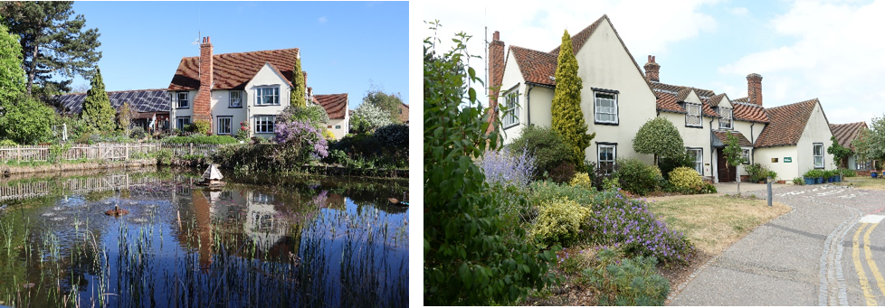

Every year we support more than 4,100 local people facing dying, death and bereavement.
By focusing on their physical, emotional and spiritual needs, we aim to bring comfort and relief to all those who need it, offering the people of north east Essex individual care and total support, regardless of their diagnosis or personal circumstances.
By visiting them in their homes, over the phone with our 24/7 advice line, and at the Hospice in Colchester, through all the smiles and all the tears we guide those who need us, because we believe in making every memory matter.
Not only do we support local people in our community facing incurable illness, but we also support adults and children living in north east Essex through bereavement, regardless of how or where their loved one died.
St Helena is an independent charity, providing our services free of charge. The equivalent of 7 out of 10 of the patients and families we care for and support are funded by people in our local community giving donations, buying from our shops, playing our lottery and leaving gifts in Wills.
We rely on the help and generosity of our fundraisers, donors and volunteers to continue to provide our services. Without them we wouldn’t be here.
What does the role entail?

Place of work | Manningtree
Salary | £27,610.20
Contract type | Permanent
Reports to | Area Manager
Manages | Assistant Manager(s), Donation Centre, retail and cafe staff and volunteers across the Manningtree site

- Take your career to the next level working with amazing like-minded people
- Work for a company who gives you a platform to do amazing things
- Be in a job where you really make a difference

What are we looking for?
Customer Focus – builds positive relationships with customers, donors and volunteers, ensuring everyone feels welcomed, valued and appreciated.
Leadership and Team Development – leads by example, encouraging and supporting others to give their best while creating a positive, inclusive team environment.
Organised and Reliable – Take pride in maintaining high standards, managing priorities effectively and ensuring the shop operates efficiently and safely.
Proactive and Resilient – approaches challenges with a positive attitude, uses initiative to find solutions and remains calm and adaptable in a fast-paced environment.

JOB DESCRIPTION

JOB OVERVIEW
JOB TITLE | Retail, Cafe and Donation Centre Site Manager
DEPARTMENT | Retail
LOCATION | Manningtree
REPORTS TO | Area Manager

KEY WORKING RELATIONSHIPS
- Customers, donors and the local community  - Shop staff, Assistant Manager(s) and volunteers  - Cafe customers, food and drink suppliers and approved service contractors  - Area Manager and wider Retail leadership team  - Donation Centre, E-commerce, Retail Administration  - Finance | - Marketing and Communication,  - Volunteer Services, People & Culture,  - Health & Safety and Estates  - Relevant cafe support teams  - Approved suppliers, contractors, recycling partners and community partners
KEY PRIORITIES
To lead a welcoming, safe and commercially successful St Helena shop and cafe that maximise sustainable income, provide an excellent customer and donor experience, develop an engaged team of staff and volunteers, strengthen St Helena’s profile within Manningtree, and support the effective receipt, processing, storage and movement of donated stock. Develop a programme of sustainability/upcycling workshops.The postholder will oversee the day-to-day cafe operation and complete the role-specific training required to do so safely and confidently.
Lead the day-to-day operation of the Manningtree shop and cafe, delivering agreed income, contribution, Gift Aid and other performance objectives.
Create an excellent customer, donor and cafe experience through service, shop and cafe presentation, stock availability, food and drink quality, workshops and local relevance.
Recruit, lead, develop and retain a capable, inclusive team of paid staff and volunteers across the shop and cafe.
Ensure the efficient receipt, sorting, safe storage, control and movement of donated stock, working closely with the Donation Centre, the logistic team and other shops.
Ensure the shop and cafe follow all current approved policies, procedures, SOPs, food and food-/product-safety controls and mandatory training requirements.
Run the cafe safely and efficiently, including food hygiene, allergen controls, stock ordering, waste reduction, cleaning, cash handling and customer service, with training provided for the role.
Promote the shop through suitable local content and community activity within brand, social media, consent and approval requirements.
Protect St Helena’s people, donated goods, assets, charitable funds, information and reputation.
DUTIES & RESPONSIBILITIES
Site leadership and integrated operations
Provide visible leadership across the complete Manningtree site and ensure retail, cafe, workshops and Donation Centre priorities are coordinated effectively.
Set clear daily and weekly priorities across all three areas, balancing trading, cafe service, donation processing, stock flow, staffing, safety and customer needs.
Maintain suitable management and operational cover across the site, respond to disruption and escalate material risks or resource gaps to the Area Manager.
Ensure effective communication and handovers between retail, cafe and Donation Centre teams so activity is coordinated and issues do not fall between operational areas.
Take overall responsibility for site presentation, housekeeping, access, security, premises checks, contractor coordination and operational readiness.
Monitor site-wide performance, capacity, staffing, incidents and compliance, implementing practical improvement actions and providing clear updates to the Area Manager.
Commercial performance and customer experience
Manage daily trading to maximise income and net contribution from donated goods, new goods, café, and approved initiatives.
Develop and lead a programme of sustainability- & upcycling- workshops to promote within the wider community
Understand the shop budget and key performance indicators, monitor results and implement improvement actions with the Area Manager.
Maintain strong pricing, merchandising, display, replenishment and seasonal standards.
Promote Gift Aid accurately and maintain the required customer conversation, labelling and audit trail.
Deliver courteous, inclusive customer and donor service and resolve concerns within authority levels.
Use customer feedback, local knowledge and available data to improve sales, donations and community reach.
Cafe operations
Lead the day-to-day operation of the cafe, ensuring a welcoming, efficient and consistent service that supports income and customer experience objectives.
Complete all required cafe, food hygiene, allergen awareness, equipment and safety training before undertaking controlled activities independently; ensure relevant staff and volunteers are trained and records are maintained.
Ensure food and drink are received, stored, prepared, displayed and served in line with approved food-safety procedures, temperature controls, date checks and manufacturer instructions.
Apply approved allergen controls, provide accurate information from authorised sources and escalate any uncertainty rather than guessing.
Manage cafe ordering, availability, portion control and wastage to support quality, value and financial performance.
Maintain high standards of cleanliness and hygiene across food-preparation, service, seating, storage and washing-up areas, completing required cleaning and monitoring records.
Ensure cafe equipment is used safely, checked as required and removed from use or reported promptly if faulty.
Monitor cafe sales, costs, customer feedback and waste, and agree improvement actions with the Area Manager.
Support and coach staff and volunteers to deliver friendly service and comply with all cafe procedures, while recognising that role-specific training will be provided.
Donation Centre operations, stock processing and distribution
Ensure the safe and efficient receipt of donations, ensuring donors are welcomed and goods are moved promptly into the approved sorting process.
Ensure donated goods are sorted, checked, priced, stored and selected appropriately to maximise income and comply with current product and quality standards.
Ensure that there are clean, organised and secure back-of-house areas with safe access routes, clear storage locations and strong housekeeping.
Monitor stock levels, Donation Centre capacity, seasonal need and rate of sale; allocate, transfer or redistribute stock across the Manningtree site and other shops to achieve the best return.
Prepare stock transfers accurately and maintain any required records for goods received, sent, recycled or disposed of.
Identify high-value, specialist, collectable, retro or unusual items and route them to approved e-commerce, specialist or alternative sales channels.
Apply clear controls for staff and volunteer access to donated stock, staff purchases and movement of goods to protect stock and public confidence.
Follow approved recycling and disposal arrangements, maximise legitimate return and minimise waste.
Support agreed collections, deliveries and logistics activity, ensuring goods are ready, access is safe and relevant information is communicated.
People leadership and volunteer management
Recruit, welcome, induct, train, coach and support paid staff and volunteers across retail, café, workshops and Donation Centre activities in line with approved processes.
Plan fair, effective rotas within agreed budgeted hours and maintain suitable leadership and operational cover across the retail shop, cafe and Donation Centre and events.
Allocate retail, cafe and Donation Centre tasks according to competence, completed training and operational need, ensuring controlled activities are undertaken only by appropriately briefed, trained and authorised people.
Set clear expectations, recognise contribution and create an inclusive environment where people can speak up.
Address conduct, capability, attendance, service or teamwork concerns promptly with appropriate support.
Complete regular check-ins, annual appraisals and development actions for direct reports.
Policies, SOPs, quality and compliance
Ensure that all current approved policies, procedures, SOPs, work instructions, food-safety controls and site-specific documents are adhered to, and staff and volunteers are aware of their contribution to this.
Complete required role-specific cafe training and brief or train relevant staff and volunteers when procedures are introduced or revised, removing superseded practices and retaining evidence where required.
Carry out required retail and cafe audits, logs and checks, including food-safety, allergen, temperature and cleaning records where applicable; take corrective action and escalate breaches, unsafe practice, suspected fraud, loss or near misses.
Contribute feedback to improve Retail procedures while continuing to follow the approved process until change is formally agreed.
Store promotion, content and community engagement
Plan local activities and community groups, that supports footfall, donations, sales, volunteer recruitment and awareness of St Helena.
Create accurate, engaging content about stock, displays, events, promotions and donation needs for approved channels.
Work with Marketing and Communications and Retail colleagues to follow brand standards, campaigns and approvals.
Follow current social media guidance, including authorised access, account security, confidentiality, data protection, safeguarding, copyright and consent.
Keep promotional prices, dates and details accurate and remove or update out-of-date content.
Build appropriate local relationships and seek approval before committing St Helena to partnerships, expenditure or public statements.
Health, safety, safeguarding and security
Maintain safe retail, cafe, Donation Centre, front-of-house, back-of-house, storage, loading and external site environments for customers, donors, staff, volunteers and contractors.
Complete, review and act on relevant site risk assessments, including fire, manual handling, lone working, COSHH, storage, loading, vehicles, work equipment, cafe equipment, hot liquids, slips and trips, food safety and individual requirements.
Ensure emergency, incident, first-aid, fire and evacuation arrangements are understood and recorded.
Act as principal key holder where required and follow opening, closing, alarm, cash security and emergency call-out procedures.
Ensure the complete site, premises, external areas, storage, racking, fixtures and equipment are safe, secure and maintained; coordinate reporting and follow-up of defects and prevent unsafe use.
Recognise and report safeguarding concerns in line with current policy.
Finance, records and systems
Ensure all financial tasks are completed accurately and on time, including controlling expenditure and additional hours within delegated authority and budget.
Maintain accurate records for sales, Gift Aid, cafe stock and waste, stock transfers, staff purchases, training, food-safety checks, safety, incidents and maintenance.
Use approved Retail, finance, people and reporting systems accurately and protect logins, personal data and sensitive information.
General Responsibilities
Attend Retail meetings, training and governance briefings and share learning across the Retail estate.
Work with the Area Manager to support agreed trials, events, campaigns and operational changes.
Ensure that GDPR guidelines in relation to confidentiality are followed
Use charitable funds, stock, equipment and time sustainably, efficiently and only for authorised purposes.
Demonstrate St Helena’s values and expected behaviours and participate in annual appraisal and continuing development.
This job description is not exhaustive. Duties and emphasis may change to reflect service needs following appropriate consultation with the post holder.

GENERAL - Applicable to all roles at St Helena
All of the above activities are governed by the operational policies, Standing Financial Instructions, policies and procedures and standards of St Helena as well as legislation and professional standards and guidelines.
All employees must comply with St Helena’s Equal Opportunity Policy and must not discriminate on the grounds of sex, colour, race, ethnic, or national origins, marital status, age, disability, sexual orientation or religious belief.
Employees have a responsibility to themselves and others in relation to managing risk, health and safety and will be required to work within the policies and procedures laid down by St Helena. All staff have a responsibility to access occupational health, other staff support services and/or any relevant others in times of need and advice.
All employees have the right to work in an environment which is safe and to be protected from all forms of abuse, violence, harassment and undue stress. All employees are responsible for helping to ensure that individuals do not suffer harassment or bullying in any form. All employees will be personally accountable for their actions and behaviour in cases of complaint of harassment or bullying.
St Helena is a smoke free organisation. Smoking is not allowed in any St Helena premises. If you would like help to give up smoking you should contact your GP or call the NHS Stop Smoking Help Line.
St Helena is a charity and all staff are responsible to ensure that funds are spent in the most sustainable and efficient way. Staff may also be encouraged to join fundraising and other business-related activities to promote the charity’s financial well-being.
PERSONAL DEVELOPMENT
Be aware of own development needs and take appropriate action. Keep updated of evidence based practice and government policies related to care. Act as an effective role model at all times.
PROFESSIONAL DUTIES
To maintain personal professional status, ensuring that the requirements laid down by the relevant professional body for registration are compliant.
Exercise professional accountability as guided by the relevant professional body and maintained in accordance with the policies of the department and St Helena.
ANNUAL APPRAISAL
The post holder will be appraised on an annual basis and the process will include a review of the past year’s performance, setting of aims and objectives for the coming year and identification of educational needs.
TRAINING
All staff will undertake such training as is necessary to perform the duties allocated and any mandatory requirements of St Helena. This will include mandatory training in line with your job role.
QUALITY
St Helena aims towards maintaining the goodwill and confidence of its own staff and of the general public. To assist in achieving the objective it is essential that at all times, employees carry out their duties in a courteous and sympathetic manner.
CONFIDENTIALITY
Your attention is drawn to the confidential nature of information collected and used throughout the NHS. The unauthorised use or disclosure of patient, staff or other personal information is a dismissible offence. The unauthorised disclosure of information could also result in a prosecution for an offence, or action for civil damaged, under GDPR.
SAFEGUARDING CHILDREN AND VUNERABLE ADULTS
All St Helena employees are required to act in such a way that at all times safeguards (and promotes) the health and well-being of children and vulnerable adults. Familiarisation with and adherence to St Helena safeguarding policies is an essential requirement of all employees as is participation in related mandatory/statutory training.
VALUES AND BEHAVIOURS
St Helena’s core values and behaviours will be embedded in our recruitment, training and development review and decision making process.
Bold | In an ever-changing world, we have the confidence and determination needed to innovate, stand out from the crowd and make a real difference every day.
Passionate | We love what we do and we are committed to our cause because it means everything to the people in our community who need our help.
Caring | People will always come first at St Helena. Everyone  is welcome and everyone will be looked after as though they are a part of our extended family.
This job description is not an exhaustive document but is a reflection of the current position. Details and emphasis may change in line with service needs and after consultation with the post holder.

PERSON SPECIFICATION

ATTIRIBUTE | ESSENTIAL | DESIRABLE
Qualifications | Good standard of literacy and numeracy demonstrated through qualifications or equivalent experience.  Willingness and ability to complete the training required to oversee the cafe and Donation Centre safely. | Relevant retail, leadership, customer service, logistics or health and safety qualification.  Food Safety & Hygiene certificate
Experience | Proven management experience in retail, hospitality, warehousing, logistics or a comparable customer-facing operation;  People Management  Cash handling and stock control; | Charity retail management; cafe, catering or hospitality experience; Donation Centre, warehouse or logistics management;  Experience of managing volunteers;  Experience of budgets, KPIs or Gift Aid.
Skills & Knowledge | Able to drive sales, price and merchandise effectively,  Manage Donation Centre processing and allocation, monitor site-wide stock flow, organise storage, control waste and turn performance information into action.  Experience of managing risks and escalation of concerns.  Sound understanding of health and safety, product safety, food hygiene, allergen awareness, security, or willingness to develop this knowledge through provided training.  Confident using Microsoft 365 and retail systems; able to create accurate store content and use approved channels responsibly.  Able to work a rota including weekends; travel to other St Helena locations if required; undertake practical retail, cafe, Donation Centre, stock and donation-handling duties with reasonable adjustments where needed; complete all required training. | Experience of, e-commerce, and or high-value goods,  Experience/understanding of cafe ordering, food and drink stock control,  Experience of working with partner organisations eg recycling  Understanding of audits, risk assessment, fire safety, lone working, COSHH, manual handling, food-safety checks, allergen controls or category-specific product safety.  Social media content, retail photography, templates or digital performance information.  Full driving licence and access to transport where required operationally.
Communication | Able to recruit, train, motivate, coach and organise a mixed retail, cafe and Donation Centre team  Communicate at all levels in all situations including difficult conversations in an appropriate and timely way. | Appraisals, attendance or performance processes and volunteer development.
Qualities | Commercially minded;  Organised approach to workloads  Works well under pressure;  Has a flexible approach  Practical and creative | Knowledge of St Helena, and the local community.

What is the team like?
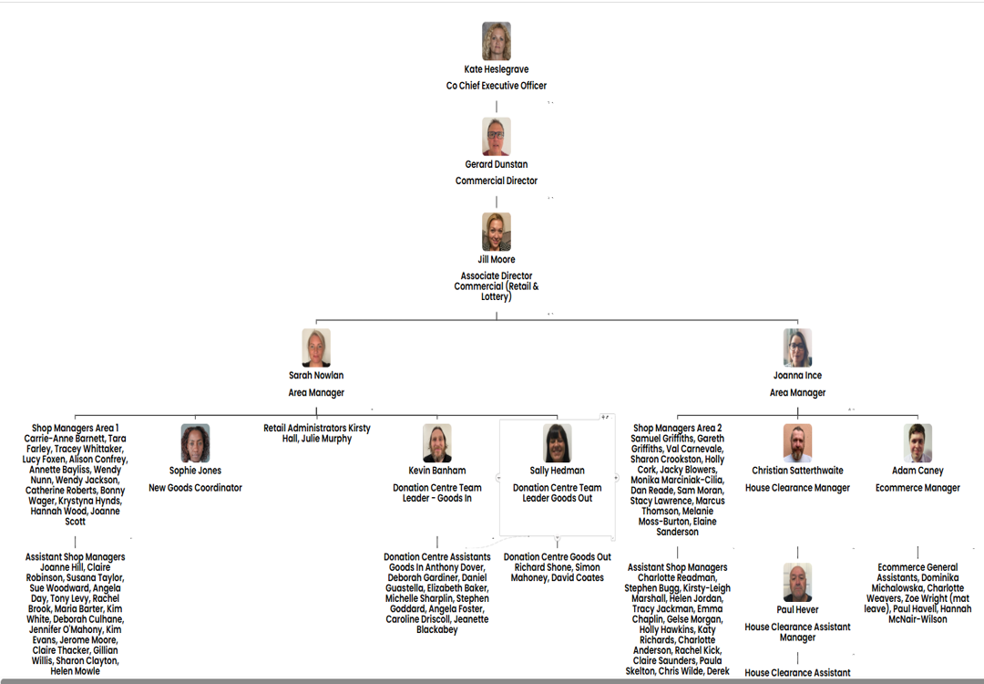
Meet some of the team
Commercial Director – Gerard Dunstan
Associate Director Commercial – Jill Moore

Area Manager – Sarah Nowlan

Area Manager – Jo Ince

What is the culture like?
Our values are incredibly important to us. But at St Helena, values are much more than just words…

They are feelings….
“It takes an amazingly special place with exceptionally special people to make the hardest times of your life turn into the most precious and so full of love.”

The passion
Whether you work within the clinical team, one of our support services or in the commercial team, each and every team member is incredibly passionate about what they do.
Working for St Helena is a privilege. There’s not many companies you could work for that really make a difference to the local community as St Helena does.
This isn’t just a belief held by those working here; it’s feedback we often receive from the patients and families we support:

Can you really make a difference?

- Last year, we helped 4,171 patients and families facing incurable illness and bereavement. More than we have ever supported before!

- 47,421 calls were made to our SinglePoint 24/7 phoneline.

- £585,058 was raised from local individuals, groups, schools and businesses in the community.

- None of this can be achieved without our amazing team. Everyone plays a part!

The benefits
Not only is working at St Helena rewarding, but there are also a huge number of benefits too!
Next steps
We hope we’ve given you a bit of an idea of what an amazing place St Helena is to work and you’re keen to find out more!
Here are the next steps:
- To find out more about St Helena, please visit our website www.sthelena.org.uk

- Apply for the position!

- Please contact us on the details below if you have any questions before or after you apply, we’ll be happy to talk through!

- Follow us on social media @StHelenaHospice to keep in the loop!

We look forward to meeting you!
Contact us:
Jo Ince
jince@sthelena.org.uk

Registered Charity Number 280919. Registered Office: Myland Hall, Barncroft Close, Highwoods, Colchester, CO4 9JU

